Week 5 : Microservices

Microservices with Spring Boot 3 and Spring Cloud

Microservices with API gateway:

**Creating Microservices for account and loan:**

Create REST Controller

AccountController.java:

package com.cognizant.account;

import org.springframework.web.bind.annotation.*;

@RestController

@RequestMapping("/accounts")

public class AccountController {

@GetMapping("/{number}")

public Account getAccount(@PathVariable String number) {

return new Account(number, "savings", 234343);

}

static class Account {

public String number;

public String type;

public double balance;

public Account(String number, String type, double balance) {

this.number = number;

this.type = type;

this.balance = balance;

}

}

}

**Its shown:**

{

"number": "00987987973432",

"type": "savings",

"balance": 234343

}

LoanController.java:

package com.cognizant.loan;

import org.springframework.web.bind.annotation.*;

@RestController

@RequestMapping("/loans")

public class LoanController {

@GetMapping("/{number}")

public Loan getLoan(@PathVariable String number) {

return new Loan(number, "car", 400000, 3258, 18);

}

static class Loan {

public String number;

public String type;

public int loan;

public int emi;

public int tenure;

public Loan(String number, String type, int loan, int emi, int tenure) {

this.number = number;

this.type = type;

this.loan = loan;

this.emi = emi;

this.tenure = tenure;

}

}

}

Its Shown  
{

"number": "H00987987972342",

"type": "car",

"loan": 400000,

"emi": 3258,

"tenure": 18

}

Output:

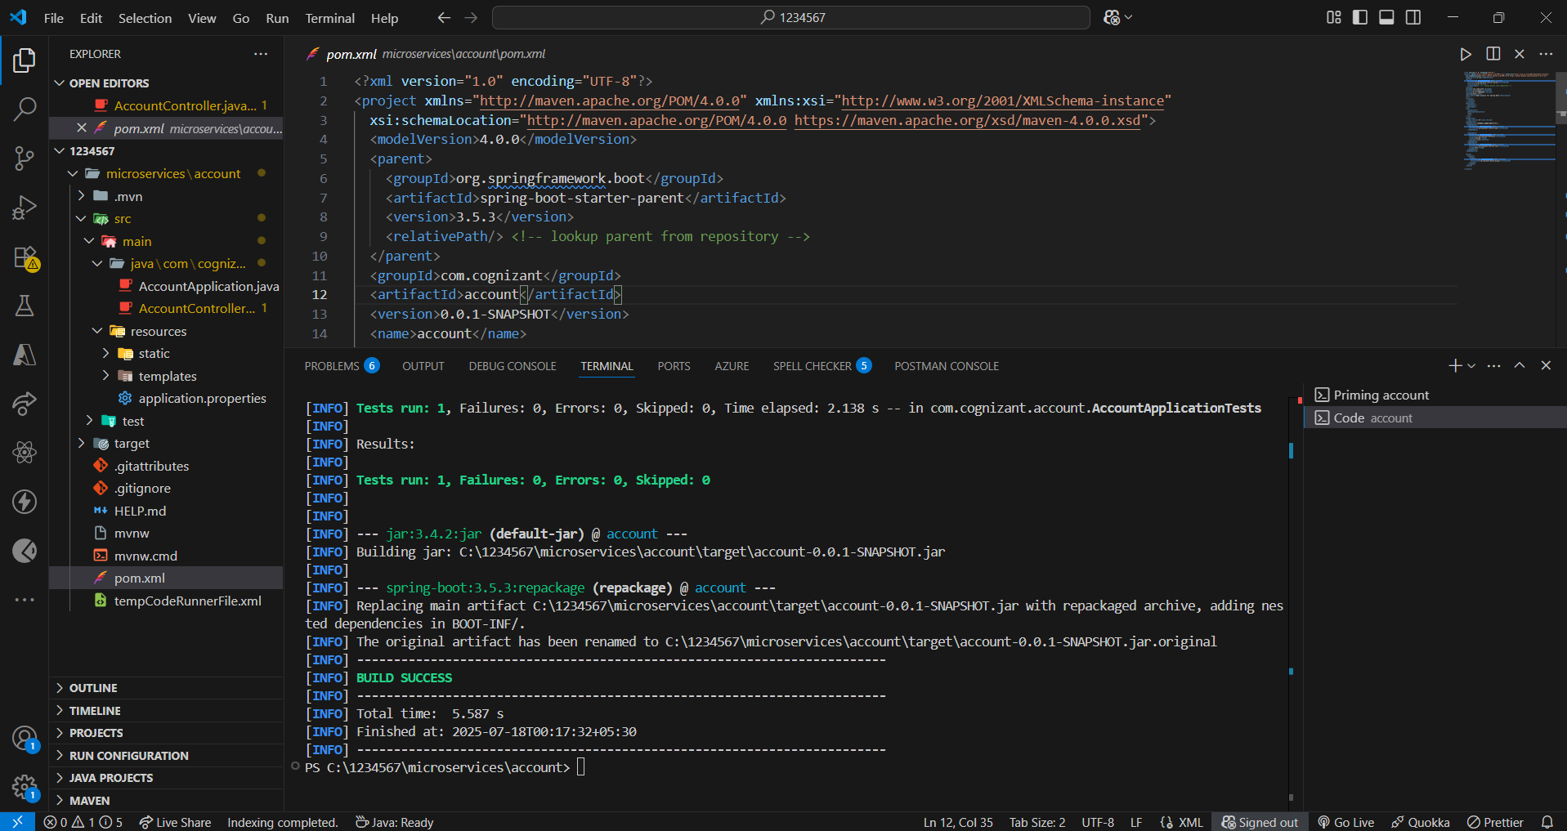

Create and Launch Eureka Discovery Server

EurekaDiscoveryServerApplication.java

@SpringBootApplication

@EnableEurekaServer

public class EurekaDiscoveryServerApplication {

public static void main(String[] args) {

SpringApplication.run(EurekaDiscoveryServerApplication.class, args);

}

}

application.properties

server.port=8081

spring.application.name=loan-service

eureka.client.service-url.defaultZone=http://localhost:8761/eureka

server.port=9090

spring.application.name=api-gateway

# Eureka config

eureka.client.service-url.defaultZone=http://localhost:8761/eureka

# Route lowercase

spring.cloud.gateway.discovery.locator.enabled=true

spring.cloud.gateway.discovery.locator.lowerCaseServiceId=true

LogFilter.java:

package com.cognizant.apigateway.filters;

import org.springframework.cloud.gateway.filter.GlobalFilter;

import org.springframework.core.annotation.Order;

import org.springframework.stereotype.Component;

import reactor.core.publisher.Mono;

import org.springframework.web.server.ServerWebExchange;

import org.springframework.cloud.gateway.filter.GatewayFilterChain;

import java.util.logging.Logger;

@Component

@Order(1)

public class LogFilter implements GlobalFilter {

Logger logger = Logger.getLogger(LogFilter.class.getName());

@Override

public Mono<Void> filter(ServerWebExchange exchange, GatewayFilterChain chain) {

logger.info("API Gateway - Request path: " + exchange.getRequest().getPath());

return chain.filter(exchange);

}

}

pom.xml:

<dependencyManagement>

<dependencies>

<dependency>

<groupId>org.springframework.cloud</groupId>

<artifactId>spring-cloud-dependencies</artifactId>

<version>${spring-cloud.version}</version>

<type>pom</type>

<scope>import</scope>

</dependency>

</dependencies>

</dependencyManagement>

Output:

